# **Table of Contents**

Table of Contents 1

Steps to Configure Network Load Balancer 2

**Diagram** 2

**High-level steps** 2

**Screenshots for Target Group Creation Process** 4

**Screenshots for Network Load Balancer creation process** 8

# Steps to Configure Network Load Balancer

### **Diagram**

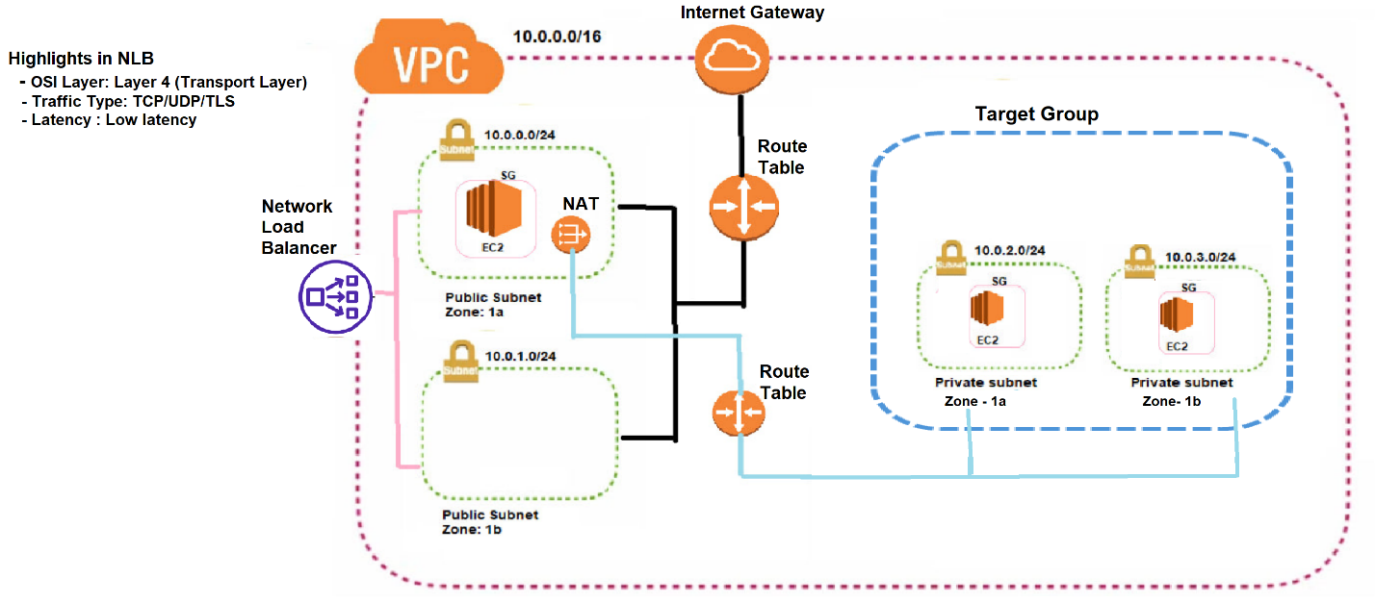

### **High-level steps**

1. Create a VPC.
2. Create an Internet Gateway and attach it to the VPC.
3. Create two public subnets: one in Availability Zone 2a and another in 2b. Also, create a private subnet in 2a.
4. Create a route table
5. Associate the Internet Gateway, and link it to the public subnets in Availability Zones 2a and 2b.
6. Create a NAT Gateway using the public subnet in AZ 2a.
7. Create a route table for the private subnet in AZ 2a
8. Associate it with the NAT Gateway and private subnet 2a
9. Create a security group with inbound rules for SSH and HTTP access.
10. Launch an EC2 instance in the public subnet in AZ 2a and another EC2 instance in the private subnet in AZ 2a and private subnet in AZ 2b
    1. Access instance created on private subnet through instance created on public subnet.
    2. Install Apache webserver on private server using below commands
11. *sudo su -*
12. *sudo yum install httpd -y*
13. *sudo systemctl start httpd*
14. *sudo systemctl enable httpd*
15. *cd /var/www/html*
16. *vi index.html*
17. *add blow html code*

*<h1>Welcome </h1>*

1. *ESC then :wq*
2. *Hit enter*
3. Create a target group and add the private instance in AZ 2a and in AZ 2b.
4. Set up a Network Load Balancer with Availability Zones 2a and 2b.
5. Copy the DNS name of the Load Balancer and open it in an internet browser.
6. If all configurations are correct, the index home page should be displayed.

**Below screenshots are related from step 11**

### **Screenshots for Target Group Creation Process**

**Navigate to Target Groups**:

* In the left-hand menu, scroll down to **Load Balancing** and select **Target Groups**. Click **Create target group**.

**Configure Target Group Settings:**

* **Choose Target Type** as **Instances** if you’re attaching EC2 instances.

**Target Group Name: Enter a name for your target group (e.g., MyTCP-TG).**

**Protocol**: Choose **TCP**.

**Port**: Specify the port that your instances (e.g., 80 or 443).

**IP address type**: IPv4

**VPC: Select the VPC where your targets are located.**

**Configure Health Checks**:

Click **Next** to register targets

**Select Instances**: Choose the instances (Private) you want to register with this target group

**Ports for Selected Instance :** specify the portwhere it will receive traffic**.**

click **Create target group**.

### **Screenshots for Network Load Balancer creation process**

On the left sidebar, scroll down to **Instances** and click on **Load Balancers**. Click **Create Load Balancer**

choose **Network Load Balancer**: Click Create

**Basic Configuration**:

* **Name**: Enter a name for your load balancer (e.g., MyTCP-NLB).
* **Scheme**: Choose **Internet-facing**
* **IP Address Type**: Choose **IPv4**

**Choose the VPC**

**Choose Availability Zones**

**Choose Security Group**

**Choose Target Group**

**Click Create Load Balancer to finalize the configuration**

**Verify Target Group Association**:

* Go back to the **Target Groups** section.
* Check that the targets are **healthy** and available to receive traffic.

To verify that your **Network Load Balancer (NLB)** is working correctly, you can test it by accessing its DNS name in a web browser, such as Internet Explorer (or any browser of your choice)

* Copy this DNS name.
* Open **Internet Explorer**

•

